The Catholic University of America
School of Architecture and Planning

ARPL 601-602-701
Urban Practice Studio
Fall 2015

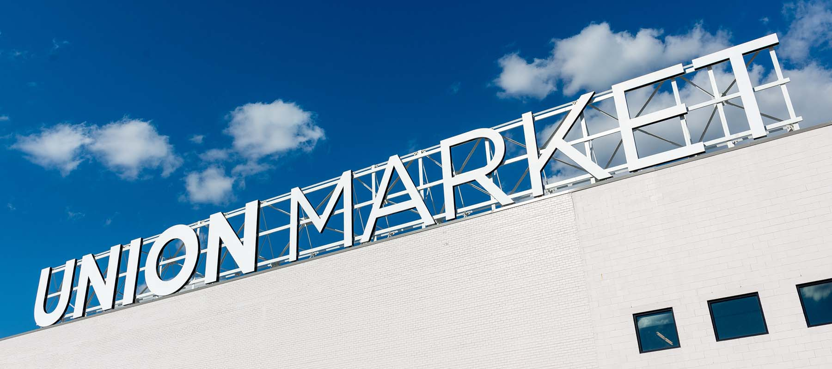

Activating an Urban Enclave
Erin Estep, AIA
Ayers Saint Gross

“Nothing is experienced by itself, but always in relation to its surroundings, the sequences of events leading up to it, the memory of past experiences”
Image of the City, Kevin Lynch

As Washington, DC begins to fill the “missing holes” in our built environment, how do we move to the next phase of added density within this urban context? How does the city begin to not just “re-use” buildings, but build onto existing structures and diversify uses?

The Florida Avenue Market in Northeast DC will serve as a case study for examining the process of puncturing and activating and urban enclave.

Until the early 20th century, Washington DC's primary public market was the Center Market located near present day Federal Triangle. Constructed in 1802, the Center Market supplied a variety of goods and services for both private and commercial consumption and, as such, became an urban destination. With the development of Federal Triangle in the 1920s, the market moved to its present day location in NE in 1931. This market thrived for many decades, but as suburban warehouses and super markets emerged, it became vacant and fell into disrepair in the 1980’s and 1990’s. The original Union Terminal Market building was dilapidated, but following renovations in 2012 has become an attraction for local vendors. The remaining buildings are currently filled with haphazard flea markets, various food stalls, and wholesale items.

Background Information
en·clave ˈenˌklāv noun: enclave; plural noun: enclaves
- a portion of territory within or surrounded by a larger territory whose inhabitants are culturally or ethnically distinct; a place or group that is different in character from those surrounding it.

Since its conception, strong elements bind the site and re-enforce an enclave: Florida Avenue to the south, 6th Street to the east (and Gallaudet University), New York Avenue to the north, Metro and Amtrak rail lines to the west. While a few borders have been engaged, a few major edges remain untouched. The original two-story buildings appear to have very few renovations over the years. Mainly brick and masonry block buildings line concrete streets; “stalls” line the streets.

Design Intentions
This studio will ask students to critique existing conditions and proposed future work (Small Area Plan, etc). Students will develop a critical eye for site cues and develop answers to questions such as: How do cars move through the site? How do pedestrians and bicyclists navigate the site? What are the qualities of edges? Do people tend to walk on one side of the street versus the other? Why do you think that is?

Students will study two urban practice paths to breaking urban enclaves: engaging site edges, and activating streets through mixed-use programs. Students will be asked to develop active streets and design spaces that foster innovative programs while engaging community needs.

Schedule | Short Term
Part 1: Documentation and Analysis
Site visit, site-use analysis, documentation, historical research
Preliminary Master Plan Concepts, Small Area Plan Analysis

Part 2: Cohesive Master Plan
Work in group(s)
Develop larger site moves, engagement with edges, concepts for adding density and massing
Propose mixed-use programs

Part 3: Architectural Scale
Individual work
Design program pieces that fit within the overall master plan and goals for the site

Throughout the semester, students will have opportunities to interact with various architects and designers from Ayers Saint Gross in the form of round-table discussions and office visits.

Resources
http://www.gallaudet.edu/office-of-administration/sixth-street-development/development-vision.html

http://www.gallaudet.edu/office-of-administration/sixth-street-development/additional-information.html

http://planning.dc.gov/publication/florida-avenue-market-small-area-plan-main-page

http://planning.dc.gov/sites/default/files/dc/sites/op/publication/attachments/famreduced.pdf

Image of the City Kevin Lynch
Visual Notes for Architects and Designers Norman Crowe and Paul Laseau
A Primer of Visual Literacy Donis A. Dondis
Experiencing Architecture Steen Eiler Rasmussen

